# Supermarket Data Analysis - Company XYZ

EXECUTIVE SUMMARY

# The Problem

Understanding sales trends in **Company XYZ** and determine its growth. The rise of supermarkets competition has increased. Given sales information for 3 months in each major branch located in 3 cities across the Nigeria.

# The Solution

From the analysis, I was able to deduce the statement below.

* Branch A has the highest sales
* E-pay was the most used payment slightly followed by cash.
* fashion accessories has the highest sold product line
* health & beauty has the lowest sold product line
* Male customers bought the highest quantity of Health and beauty products which is a huge surprise.
* More expensive products across all product line were purchased the least.
* The products of the cheapest total prices were purchased more.
* Unit price and quantity are inversely related i.e. as price reduces, quantity increases and vice-versa

# Highlights

Branch A has the overall lowest rating. Branch A and C are fairly similar.

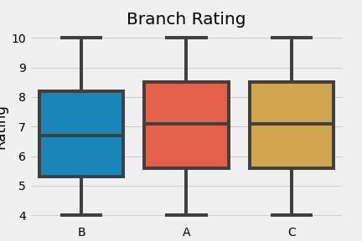

# C:\Users\SOLA\Downloads\ustacky\Images\Payment Channel for Each Branch.png

# Keys to Success

Steps necessary for business to be successful.

* Provide more resources E-pay since that is the most common payment method.
* Reducing the price of product to increase the quantity being sold.



How to use this Executive Summary Template

**Replace Sample Text**

The section titles, descriptions, questions and tips are all meant to help make it easier for you to write your executive summary. Feel free to change anything to best fit your needs and replace the text as you go.

**Theme & Font Style Customization**

This template is using font styles for headings, subtitles, paragraph text, etc. You can easily explore different fonts and colors by changing the theme under Design > Themes.

**Remove this Page**

After reviewing the terms of use, you may remove this page. The terms of use still apply, but we don’t expect you to keep this page attached to your executive summary.

Other related templates

***Business Plan Template***

<https://www.vertex42.com/WordTemplates/business-plan-template.html>

***Business Startup Costs Template***

<https://www.vertex42.com/ExcelTemplates/business-startup-costs.html>

***Business Budget Template***

<https://www.vertex42.com/ExcelTemplates/business-budget.html>

***Break Even Analysis Template***

<https://www.vertex42.com/ExcelTemplates/breakeven-analysis.html>

Terms of Use

By Vertex42.com

<https://www.vertex42.com/WordTemplates/executive-summary.html>

Executive Summary Template © 2019 Vertex42 LLC

This template, including all associated content is a copyrighted work under the United States and other copyright laws. Do not submit copies or modifications of this template to any website or online template gallery.

Please review the following license agreement to learn how you may or may not use this template. Thank you.

[**License Agreement:** https://www.vertex42.com/licensing/EULA_privateuse.html](https://www.vertex42.com/licensing/EULA_privateuse.html)